**Baseline Assessment of Faga’alu Watershed: A Ridge to Reef Assessment in Support of Sediment Reduction Activities**

**Purpose and Objective**

The primary purpose of this document is to provide local and federal partners with baseline information and survey methodologies to enable partners the ability to continue monitoring efforts and evaluate the effectiveness of management actions taken at the Samoa Maritime quarry in Faga’alu, American Samoa. This document summarizes work completed between 2012 and 2014 which was coordinated and funded by the National Oceanic and Atmospheric Administration (NOAA) Coral Reef Conservation Program (CRCP) to gather baseline data and information before management interventions were implemented to reduce land-based sources of pollution inputs to the coral reefs in Faga’alu Bay. The work described in the following sections was funded through investments made by the NOAA CRCP either directly through an internal NOAA project titled, “Comprehensive baseline assessment and pilot test of outcome performance measures in Faga’alu Bay, American Samoa”, through a Cooperative Agreement with American Samoa to the Coral Reef Advisory Group (CRAG), or through a domestic grant awarded to San Diego State University (SDSU) titled, “Monitoring and analysis of sediment accumulation and composition on coral reefs in Faga'alu Bay, American Samoa” which extended previous efforts supported by the Department of Interior – Insular Affairs Office through the CRAG.

To carry out these baseline assessments, experts from across NOAA and SDSU were asked to apply their knowledge and technical skills to develop baseline information to share with the local management authorities in American Samoa. These 2012-2014 activities describe the pre-intervention baseline data collection, analysis, and interpretation needed to evaluate the effectiveness of the intervention over the long term. In order to understand the effectiveness of the intervention, additional long-term monitoring will be required and the data from that monitoring should be compared to these baselines. The overall effort required to evaluate the effectiveness of the intervention is large, and will require a division of labor between local and federal efforts. With the baseline data collection completed through the support of the NOAA CRCP, the remainder of ongoing long-term monitoring using the methods already employed will be needed in order to determine effectiveness of the actions taken at the quarry and should transition into the hands of the local management authorities.

**Introduction**

In August 2012, Faga’alu, American Samoa was chosen by the US Coral Reef Task Force (USCRTF) as a priority watershed site for the Watershed Partnership Initiative (WPI). In 2009, the WPI was launched in Guanica, Puerto Rico and is an active effort of the USCRTF to reduce land-based sources of pollution (LBSP) by facilitating and enhancing coordination, partnerships, and contributions of agency resources and expertise to implement geographically specific integrated activities to reduce pollutant loads to coral reef ecosystems. The WPI also promotes consistent and strengthened application and enforcement of laws and authorities intended to address LBSP within the U.S. coral reef jurisdictions. Currently, the WPI is active in three watersheds: Guanica, Puerto Rico, West Maui, Hawaii, and Faga’alu, American Samoa.

In a separate process conducted in 2010 by NOAA’s CRCP to identify management priorities in the US coral reef jurisdictions, the American Samoan resource managers, invited management advisors, and science advisors identified Faga’alu as one of two priority geographies in American Samoa based on biological value, degree of risk and threat, and management effectiveness (CRCP, 2010). Additionally, as a result of the 2010 management priority setting process (NOAA, 2010) three strategic coral reef management goals were identified including the following which is aimed at reducing LBSP: “*Goal 2: Improve coastal watershed quality and enhance coral reef ecosystem function and health by reducing land-based sources of pollution*”.

In August of 2012, the Village of Faga’alu also completed its Watershed Management and Conservation Plan, which was prepared in collaboration with American Samoa’s Land-based Sources of Pollution Local Action Strategy Group. This plan identified sedimentation as a key threat to the Faga’alu watershed. By the end of 2012, with the above processes complete and the village plan as a guide, the CRCP began to provide resources and coordinate activities in Faga’alu to monitor baselines and to address the threat of LBSP, specifically the sedimentation issues and resulting turbidity found in Faga’alu Stream and Faga’alu Bay which do not pass the American Samoa Water Quality Standards (ASWQS). Excessive turbidity is in part responsible for placing Faga’alu on the 303(d) list of impaired waters according to the American Samoa Environmental Protection Agency (ASEPA). Other parameters that do not meet the ASWQS include total Nitrogen, total Phosphorus, dissolved Oxygen, and *Enterrococcus* bacteria levels.

**Context**

*Geographic*

Faga’alu is a relatively small, steep coastal watershed located southwest of Pago Pago Harbor on Tutuila Island in American Samoa (Figure 1). The watershed, including both a main channel and several small drainages, is 2.49 km2 and sits west of Faga’alu Bay. The bay is bounded on the north by Tulutulu Point and on the south by Niuloa Point. Within the watershed there is Faga’alu Village (population 910, US Census 2010), the only hospital in American Samoa, a popular public beach park, Matafao Elementary School, and several businesses – including Samoa Maritime Company, an open pit rock quarry located above the village. The excess sediment discharged from Faga’alu watershed is believed to come from the quarry, making the Samoa Maritime quarry a target for mitigation actions to reduce the amount of sediment released into Faga’alu Bay (Messina et al., forthcoming). The sediment flows from the quarry into Faga’alu stream then out into Faga’alu Bay where it may degrade coral health.

*Rainfall*

There are two subtle rainfall seasons: a drier winter season, from June through September and a wetter summer season, from October through May (Izuka, 2005). During the drier winter season, the island is influenced by relatively stronger, predominantly East to Southeast Tradewinds, lower temperatures, lower humidity and lower total rainfall. During the wetter summer season the Inter-Tropical Convergence Zone (ITCZ) moves over the region, causing light to moderate Northerly winds, higher temperatures, higher humidity, and higher total rainfall. While total rainfall is lower in the drier Tradewind season, large rainfall events are still observed. Analysis of mean monthly rainfall data for the period 1971-2000 showed 75% of precipitation occurred in the wet seasons, October-May, and 25% occurred in the dry season, June-September (Perreault, 2010; Data from USGS rain gauges and Parameter-elevation Relationships on Independent Slopes Model (PRISM) Climate Group (Daly et al., 2008)). Analysis of 212 peak discharges at 11 continuous-record gaging sites up to 1990 showed 65% of annual peak flows occurred during the wet season and 35% of peak flows occurred during the drier Tradewind season (Wong, 1996).

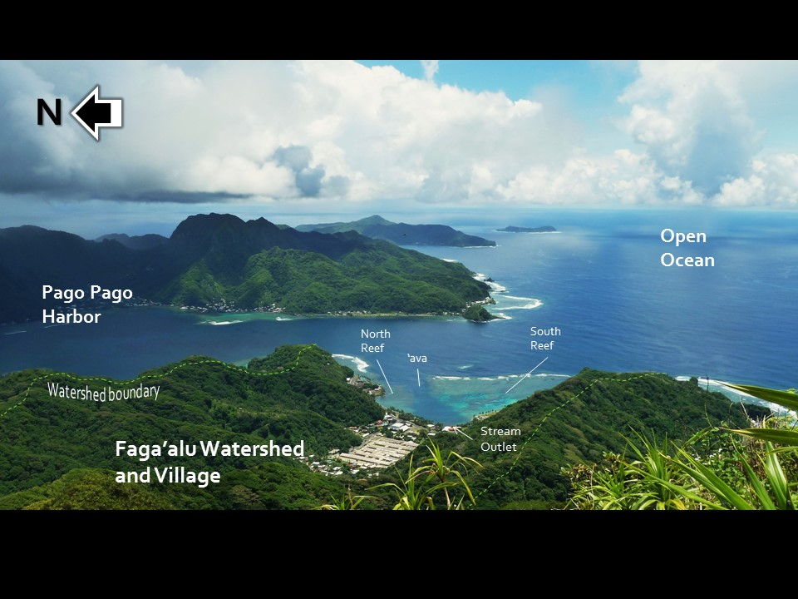

Figure 1. Overview of Faga’alu Watershed from Matafao Peak showing watershed boundaries, stream outlet, village, LBJ Hospital, and the northern and southern coral reef flats of Faga’alu Bay.

*Hydrodynamic*

Faga’alu reef is divided into two shallow reef flats by a deep channel through the reef (ava in Samoan language). Tides vary daily from approximately 0-1 m, winds are predominantly onshore east-southeast trades from March to September and northerly from October to February, and groundswells over 1 m occur throughout the year. Water is forced over the shallow reef crest by wind and waves, then flows clockwise over the southern and northern reefs, and out to sea through the ava channel to Pago Pago Harbor (Figure 2). Based on hydrodynamic measurements in Faga’alu Bay, current speeds are typically highest and residence times lowest over the southern reef; speeds are lowest and residence times highest near the stream mouth and on the northern reef. During storms, sediment-rich discharge from Faga’alu stream flows into the northwest corner of the bay, and is deflected north by the water circulation pattern, causing sediment accumulation in the northern reef and ava areas but leaving the far southern reef relatively unaffected (Messina, unpublished data).

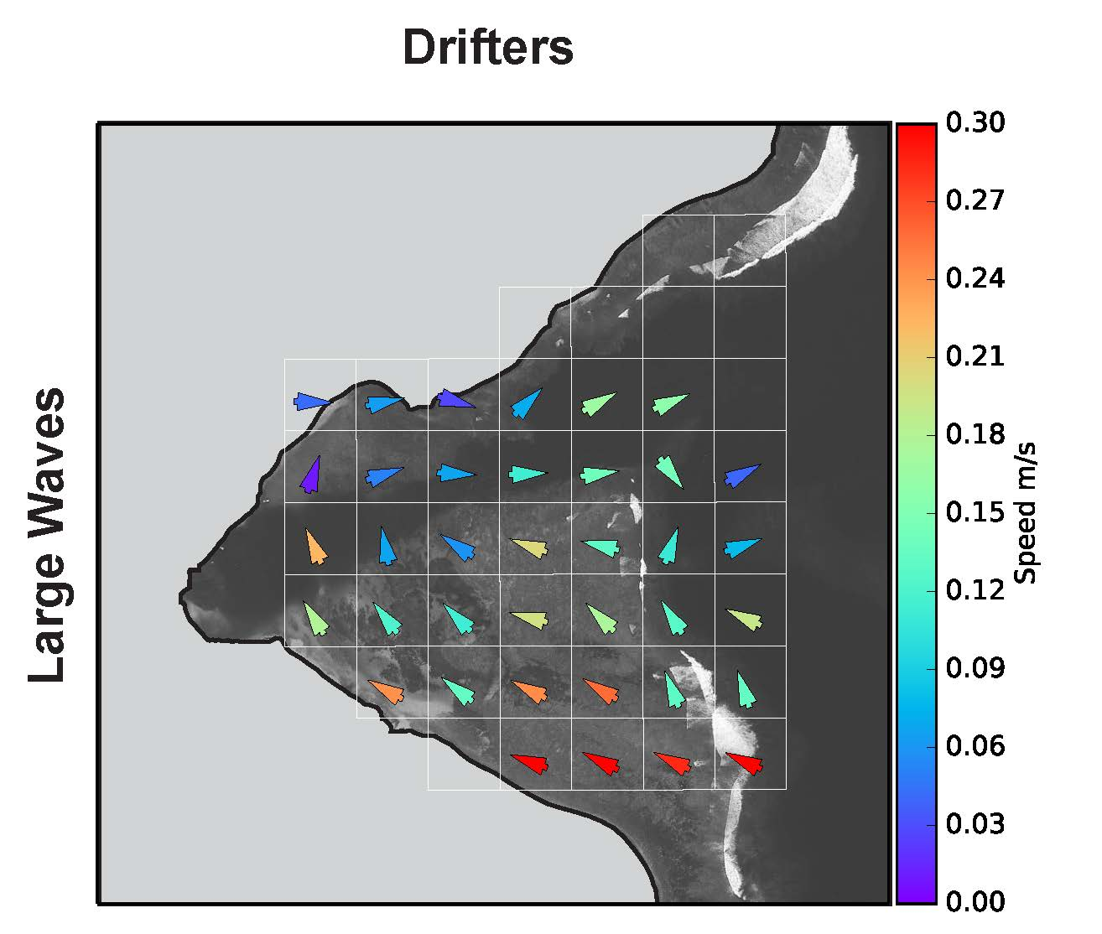

Figure 2. Gridded mean current speeds and directions for 100 m2 grid cells based on drifter data. Velocities are lower but directions are similar during small waves and wind events. Messina, unpublished data.

Owing to the relatively small volume of the bay, calculated flushing times vary from less than an hour to between one and two days. Based on data from an Acoustic Doppler Current Profiler (ADCP) deployed in the channel, flushing times are shortest during high tide and high wave events, with a total flushing time of < 1 hour during the highest observed wave and tide event. During periods of low waves, flushing times can be nearly 33 hours (Figure 3 A & B).

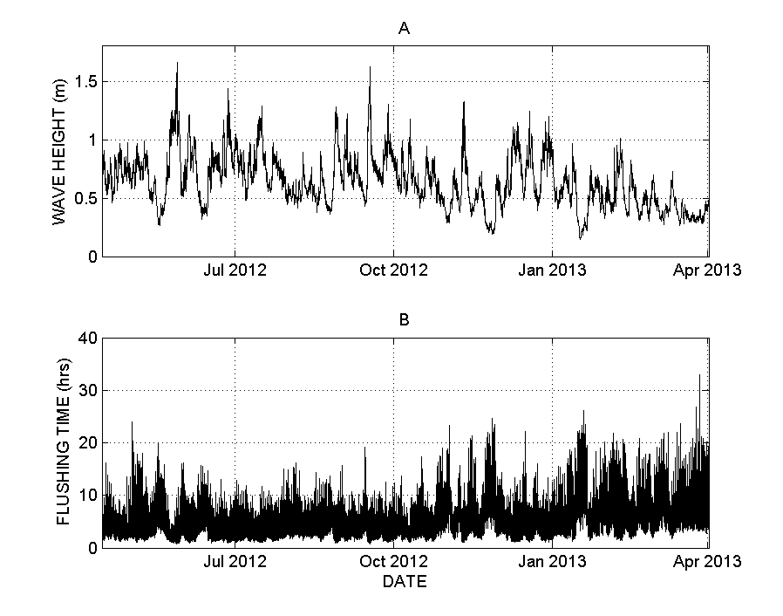

Figure 3. Faga’alu Bay (A) wave height and (B) estimated flushing time based on Acoustic Doppler Current Profiler data in the ava channel (O. Vetter, unpublished data).

**Mitigation Actions/Interventions**

Since the designation of Faga’alu as a priority site for the WPI, multiple entities, including the National Fish and Wildlife Foundation (NFWF), the Coral Reef Advisory Group (CRAG) in American Samoa, ASEPA, and NOAA CRCP have engaged in discussions with Samoa Maritime to implement a corrective action plan at the quarry. This plan included multiple steps to address both dry and wet season conditions.

1. To mitigate constant groundwater flow from coming into contact with loose/erodible sediments on the haul roads and processing area of the quarry, and to stem dry weather discharge of turbid water to the stream, two groundwater drainage diversions were added between August-November 2012 at two locations immediately below exposed rock face to intercept clean groundwater flow and direct it around the active site into the stream.
2. In 2013 the roadways within the quarry grounds were covered with larger gravel to minimize mobilization of surface sediments and reduce tracking from equipment tires during wet conditions.
3. In September-December 2014 two retention ponds were installed to capture sediment-rich runoff from the whole site, before it could be discharged into the stream during heavy rainfall conditions. The retention ponds allow the sediment-free water to percolate through the ground and into the stream, leaving the sediment behind in the retention pond.

The engineering designs for the interventions at Samoa Maritime quarry were developed by Horsley Witten Group, and were built into the corrective action plan for the quarry to implement using their own equipment and time, as well as a combination of funding from NFWF, NOAA, and CRAG to cover supplies and hauling of the excavated material from the retention ponds. Any costs exceeding the amount of funds provided were assumed by the quarry. Coordination for the on-site work was handled by ASEPA, CRAG, and NOAA CRCP staff based in American Samoa in cooperation with Samoa Maritime staff. Several site visits were conducted during the implementation of the corrective action plan to ensure that the work was in alignment with the plans prepared by Horsley Whitten with final sign off responsibility resting with technical staff at ASEPA.

**Rationale for Collection of Baseline Data**

*Sediment*

Building upon a two-year grant from Department of Interior – Insular Affairs to SDSU to measure sediment discharge from Faga’alu watershed, NOAA funded another 2 years of work in 2013 to SDSU for a project titled, “Monitoring and analysis of sediment accumulation and composition on coral reefs in Faga'alu Bay, American Samoa”, to expand the work to look at sediment composition and deposition in Faga’alu Bay. Continued stream monitoring was conducted under a project titled, “Expanding monitoring and modeling of land-based sources of pollution to priority coral reefs in American Samoa” within the CRAG cooperative agreement. The data collected through these projects provide a comprehensive baseline of natural sediment loading in the stream from the forest above the quarry, immediately below the quarry, and farther downstream where it enters the bay. Sediment loads can be extremely variable so having data collection starting in 2012 provided enough time for data gathering efforts in wet and dry seasons to cover the variability of sediment loading due to storm size prior to mitigation efforts at the quarry. The analysis presented here quantifies suspended sediment load during storms of similar sizes before the retention ponds were constructed to be able to determine the effectiveness of this intervention to allow for comparison with data to be collected after installation.

*Coral*

In order to obtain pre-intervention baselines for the coral community structure and coral demographics in Faga’alu Bay, NOAA’s capabilities in coral reef ecosystem monitoring were put into action to gather data for coral reef community structure of Faga’alu Bay. Surveys were conducted during the NOAA reef assessment and monitoring cruise in American Samoa in 2012, and additional benthic surveys focused on coral demographics were completed in 2013 by the Coral Reef Ecosystem Division (CRED) as a sub-activity of NOAA CRCP project “Comprehensive baseline assessment and pilot test of outcome performance measures in Faga’alu Bay, American Samoa”. The status of the coral community and the effects of the sedimentation on the coral reefs in Faga’alu Bay were characterized using the data collected in 2012 and 2013. This data provides baseline information that is critical to evaluate the effectiveness of reef-to-ridge management practices aimed at reducing land-based sources of pollution threats and improving coral community structure and demographics in Faga’alu Bay, American Samoa.

*Contaminants*  
Through conversations in 2013 with ASEPA, SDSU, CRAG, and the National Marine Sanctuary of American Samoa, concerns were raised about the quantity and quality of groundwater flowing through the bedrock in Faga’alu. A 2013 study prepared for ASEPA looking at decadal trends in coral reefs near watershed villages (Houk, 2013) showed that significant freshwater input, possibly due to groundwater movements, may occur on the southern coast of Tutuila thereby adding another possible source of LBSP. In 2013, the CRCP also learned that the site of the Matafao Elementary School, located on the northern shore of Faga’alu Bay, was previously a U.S. military dump site during World War II and presented the possibility to introduce some contaminants into Faga’alu Bay via groundwater movements. Thus to identify any additional stressors besides sediments from the quarry, in 2014 the CRCP funded the collection of baseline levels of contaminants from surface sediments in the watershed and the bay using standardized methods from NOAA’s National Status and Trends Program, in addition to sediment load and coral community information. This contaminant study was also a sub-activity of CRCP project “Comprehensive baseline assessment and pilot test of outcome performance measures in Faga’alu Bay, American Samoa”.

In the sections that follow, the importance of gathering baselines for each of the areas highlighted above – sediment loading, coral community structure and demographics, and contaminants – will be discussed. Additionally, for each area the following will be presented: monitoring methods used for data collection, data analysis used, pre-intervention baseline values, and an outlook of anticipated changes for each data stream as a result of the intervention.

**Section 1. SEDIMENT MONITORING AT FAGA’ALU, AMERICAN SAMOA**

Trent Biggs, Alex Messina

*San Diego State University*

**Significance**

Sediment is a key stressor to coral reefs by limiting light for photosynthesis, smothering, and promoting disease (Erftemeijer et al., 2012; Fabricius, 2005). At Faga’alu, sediment loading from the stream to the bay was monitored from 2012-2014 using measurements of streamflow and suspended sediment concentration in stream water. During 2014, sediment accumulation rates on the reef were also monitored. Many of the details of the sampling and results are in Messina and Biggs (in prep). Here, the basic methods are summarized in sufficient detail for interpretation of the data. Detail sufficient for replicating the monitoring are in the Quality Assurance Plan Protocol (QAPP).

*Rationale for storm sampling*

Most of the sediment discharge to the bay occurs during storm events. Sediment concentration in water during baseflow (low flow between storm events) is often very low, and increases rapidly with streamflow. At Faga’alu, some high sediment concentrations were observed during baseflow conditions due to consistent flow of groundwater released by quarry operations from an excavated rock face that spilled onto and ran over the quarry haul roads and aggregate washing operations, but we believe that this situation has been addressed through management at the quarry using diversion drainage and large gravel to cover the roadways within the quarry grounds. The highest concentrations and loads were observed during storm events, *thus, sampling of baseflow at a set time every week or two will not effectively measure the sediment load or the impact of management operations.* It is very important that sampling for sediment include measurements of sediment concentrations during storm events.

**Methods**

1. RAINFALL, STREAMFLOW AND SEDIMENT LOADING DURING STORM EVENTS

Sediment load at any given instant (mg/sec) is calculated as:

S = Q x SSC (1)

where Q is streamflow (aka discharge, units L/s) and SSC is suspended sediment concentration (mg/L). Q is determined from flow depth recorded by a pressure transducer and translated to discharge with a relationship between stream depth and flow rate (see section 2 below). SSC is determined from either grab samples of water taken manually during a storm (ideal), an automated sampler (Autosampler), or from continuous turbidity measurements from a turbidimeter (see section 3 below). Suspended sediment yield from a storm event (SSYEV) is calculated as the sum of the instantaneous loads (S in Equation 1) during a storm event.

*Key metric: Sediment loading during storm and inter-storm events*

1. **Rainfall monitoring**

*Rationale:* Rainfall measurements are important for determining how much water fell during a storm and the kinetic energy of the rainfall. Rainfall was almost as good a predictor of total sediment load during storms at Faga’alu as total storm or peak discharge (Figure 7), so it may be a useful proxy forsediment load estimation under pre-mitigation conditions if streamflow measurements are not available.

*Method at Faga’alu*: Tipping-bucket rain gauges were installed at the quarry (RG1) and at the Church near the outlet of Faga’alu stream to the ocean (Wx Station) (Figure 5). Tipping bucket rain gauges record every 0.01 inches of rainfall, which can be converted into rainfall intensity measurements, like 10 or 15 minute intensities. Rain gauges need to be installed with the top level and away from tall structures or vegetation that may interfere with wind or rainfall. Data is downloaded at least once per month, debris is removed from the bucket, and the batteries are checked.

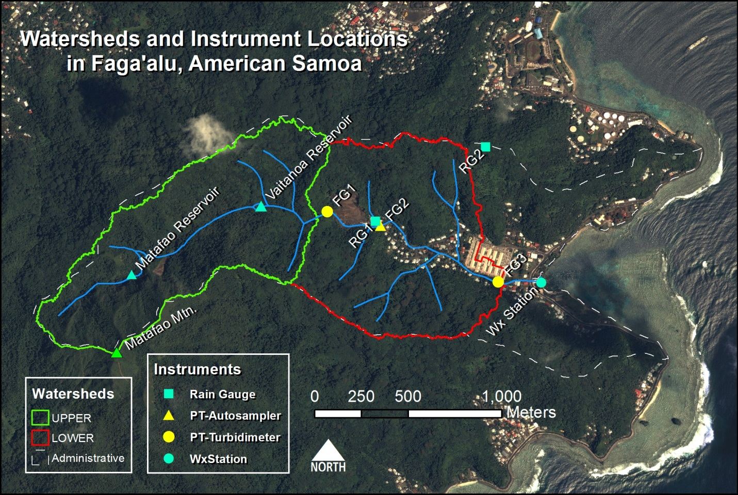

Figure 5. Location map of monitoring sites at Faga’alu. “Wx station” is a weather station with a rain gauge, wind speed, and air pressure.

1. **Streamflow monitoring**

*Rationale:* Continuous streamflow measurements (Q, also called discharge, units in volume per time) are necessary for quantifying the sediment load (Eq 1). Q is the product of the cross-sectional area of flow and the flow velocity. Since velocity varies within the stream and can be expensive to measure, Q is often estimated using measured water depth (stream stage) and a mathematical relationship between the water depth and a few manual measurements of the discharge (a stage-discharge relationship). To measure stream stage continuously, pressure transducers (PTs) submerged at the bottom of the stream measure pressure due to both atmospheric pressure and the depth of water over the PT. The pressure due to the atmosphere is measured by a nearby barometer and subtracted from the total pressure to give the stream stage at 15 min intervals. PTs are very rugged and have provided some of the most reliable data on watershed behavior at Faga’alu. Q is measured in the field with a hand-held flowmeter, by taking velocity and depth readings at intervals across the stream and calculating Q for the stream stage at that point in time. A single Q measurement typically takes approximately 15-30 min and several are needed at various stream stages to develop a robust stage-discharge relationship. SSYEVEV (see section below?)

*Method at Faga’alu*: PVC or metal tube housings were installed in Faga’alu Stream at FG1 (upstream of the quarry) and near the hospital (FG3). A staff gage was installed on the concrete pillar of the bridge near the hospital (FG3, Figure 5). The water level on the staff gage is observed and written down in a notebook at least at the deployment and retrieval of the PT to correct for any changes in the depth of the PT when deployed. Ideally, several readings of water depth on the staff gage are taken during the PT deployment period.

A stage-discharge relationship was developed using a combination of hydraulic equations and discharge measurements to calibrate the equations. See Messina and Biggs (in preparation) for more detail. The stage-discharge relationship may need updating with measurements of the cross sectional area and flow velocity if vegetation grows in the channel or if sediment deposits in the channel during storm events.

1. **Suspended sediment monitoring**

*Rationale:* Suspended sediment concentration (SSC) was measured both directly from water samples and indirectly using turbidity measurements. Grab samples are water samples taken from the stream manually using a wide-mouth bottle or with an ISCO autosampler. In the laboratory, the water sample is vacuum-filtered and the sediments are collected onto a pre-weighed filter, dried in an oven, and the dried filter and sediment are weighed. While SSC at different depths may be variable in large rivers, in small streams during storm events it is usually assumed that SSC is uniform with depth, so a grab sample provides a good measure of the average SSC. Autosamplers require regular maintenance like charging the battery, and the sampling tube can get clogged, but they can be automatically triggered by a water level sensor and collect critical storm measurements when field staff are unavailable. Field staff are still needed to retrieve the samples and perform the lab analysis. As an alternative, turbidity measurements can be used to estimate SSC by developing a mathematical relationship between SSC measured in a few grab samples and a simultaneous turbidity measurement recorded by the turbidimeter.

*Method at Faga’alu*: Using a combination of grab-sampling, autosampling, and turbidimeters, SSC was measured during ~60 storm events at Faga’alu above the quarry (FG1), just below the quarry (FG2), and at the hospital (FG3) (Figure 5). An autosampler was installed at FG2 and turbidimeters were installed at FG1and at FG3 (see Messina and Biggs in prep for details).

**Data Analysis**

***Analysis for impact assessment: Relationship between peak stormflow and sediment loading***

Annual total sediment load is often used to compare among watersheds or to assess the effectiveness of management activities. However, annual totals are influenced by the natural variability in number and intensity of storm events. The relationship between streamflow and suspended sediment concentration (Q-SSC relationship) can be used to test for a decrease in sediment at the same streamflow. At Faga’alu, the Q-SSC relationship shows higher SSC downstream of the quarry (FG2) and village (FG3), including during relatively low discharge (Figure 6). The Q-SSC relationship is highly variable, due in large part to high SSC on the rising limb of the storm hydrograph, so a simple Q-SSC relationship could not be used to separate the effects of stream discharge from the effects of land use or management activities in Faga’alu (Figure 6).

Given the large variability in the Q-SSC relationship (Figure 6), total storm loading of sediment (tons per event, SSYEV) was used to quantify sediment load and provides the baseline for detection of human activities. Storm size also controls SSYEV and needs to be accounted for in order to compare SSYEV before and after a management activity. In order to control for storm size, different storm metrics, including total storm precipitation, an erosion index, peak discharge, and total discharge, were measured using a tipping bucket rain gauge and tested for ability to explain variability in SSYEV (Figure 7). Peak discharge for a given storm (Qpeak) explained the most variability in SSYEV and highlights the difference in SSYEV between the upstream, forested watershed (FG1) and the watershed that includes the village and quarry (FG3) for a given storm size (Figure7). Management impact would be demonstrated by a change in the Qpeak-SSYEV relationship.

***Continued monitoring recommendations***

Based on the amount of scatter in the Qpeak-SSYEV relationship (Figure 7), we anticipate that SSYEV will need to be quantified for at least 10 storms in order to establish any change in the Qpeak-SSYEV relationship. Storm sampling includes taking at least 5 stream samples per storm at each monitoring location, at 5-30 minute intervals, or deployment of a continuous recording turbidimeter. If manual sampling is used, care should be taken to sample on the rising limb, peak, and falling limb of the hydrograph.

1. SEDIMENTATION IN THE BAY

*Rationale:* Sediment discharged from the watershed may or may not affect coral health on the reef depending on ocean conditions. If sediment discharge happens during a time of intense ocean circulation, deposition may be much lower than during times of quiescent ocean conditions. Therefore, monitoring sedimentation rates on the reef itself is important to determine the ultimate impact of management activities on a reef.

*Key metric: Sedimentation rates in tubes and on SedPods*

We quantified two metrics of sediment deposition, both of which may be important for coral health:

1. Gross accumulated sediment deposition is all sediment that accumulates on a surface with no resuspension. This may be important if even temporary sediment accumulation negatively affects coral organisms. Gross deposition is measured using PVC tubes, which capture all sediment that enters them and prevents resuspension.
2. Net sediment deposition is the amount of sediment that accumulates on a surface, minus what is resuspended and removed from the surface by currents induced by waves or wind. Net deposition may be important if corals are sensitive to prolonged sediment accumulation. Net deposition is measured using a flat concrete surface (SedPods), which are exposed to waves and currents, allowing sediment to get deposited and then resuspended and removed.

The tubes for measuring gross deposition are constructed from 2” PVC pipe with an end cap. SedPods for measuring net deposition are constructed from 6-inch diameter PVC pipe filled with concrete. The concrete is poured on rough plywood to give it texture that approximates the rough texture of a coral colony. Sediment is collected monthly by trained SCUBA divers, and analyzed in the laboratory for sediment weight, grain size, and composition. Details on sediment collection are in the QAPP.

*Key metric: Sediment characteristics: Fine/coarse fractions and terrestrial vs carbonate fraction*

The impact of sediment on coral may depend on the sediment size, and the fraction of the sediment that is terrestrial versus marine in origin (Erftemeijer et al., 2012). The fine fraction and terrestrial fractions may also decrease with reduced loading from the watershed. The fine fraction can be determined with simple laboratory equipment, but the methods must be followed very carefully to be consistent with other results. The terrestrial fraction is determined using combustion of the calcium carbonate in an oven (see QAPP for details).

**Baseline values**

*Stream sediment concentrations and loads:*

High concentrations of sediment were observed in 2012 during baseflow conditions (Figure 2), which we believe was due to 1) small rain events that generated runoff from the quarry but did not increase stream discharge significantly 2) in-stream construction activity (bridge) and 3) mining operations between storms, in particular washing aggregate at the quarry. Both construction and washing activities have since stopped, and high concentrations are no longer observed between storms, with some exceptions (see FG2 in 2014 in Figure 6).

The scatter in the Q-SSC relationship (Figure 6) means that it is not a good way to determine the success of management activities. Instead, there was a regular relationship between total storm sediment load and total storm rainfall, total stormflow, and peak storm flow (Qpeak) (Figure 7).  *We believe that Qpeak can be used to estimate the pre-mitigation sediment load, and compared to future measurements to quantify the impact of management on sediment mitigation.*

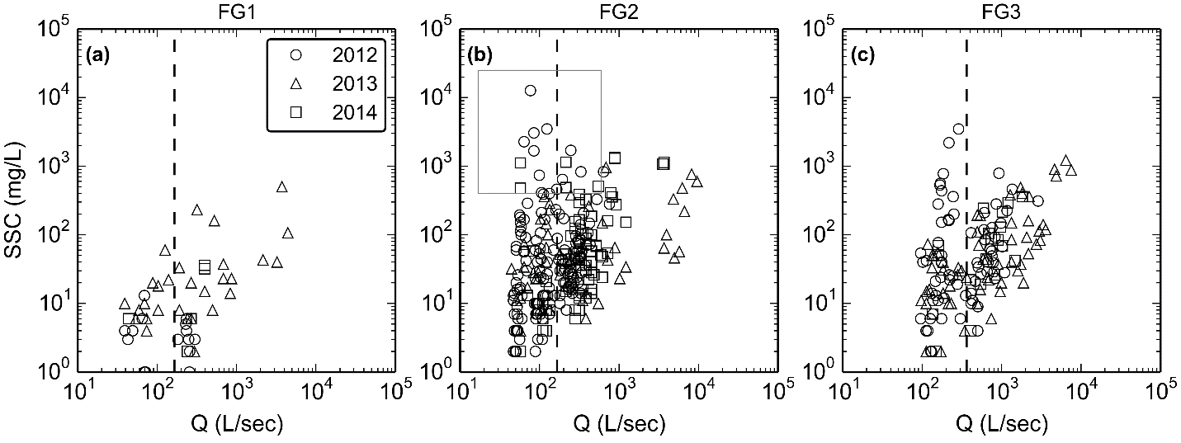

Figure 6. Discharge (Q) versus suspended sediment concentration (SSC, mg/L) at the (a) forest, (b) quarry, and (c) village sites. The box in (b) highlights where SSC was high during low streamflow, downstream of the quarry, and then slightly diluted downstream near the hospital (c). These were notably absent from the forest site (a), and are hypothesized to be caused by activities at the quarry that ceased after 2012, i.e. washing sediment from the crushed aggregate during non-storm periods, and remediation of groundwater flow eroding sediment from haul surfaces.

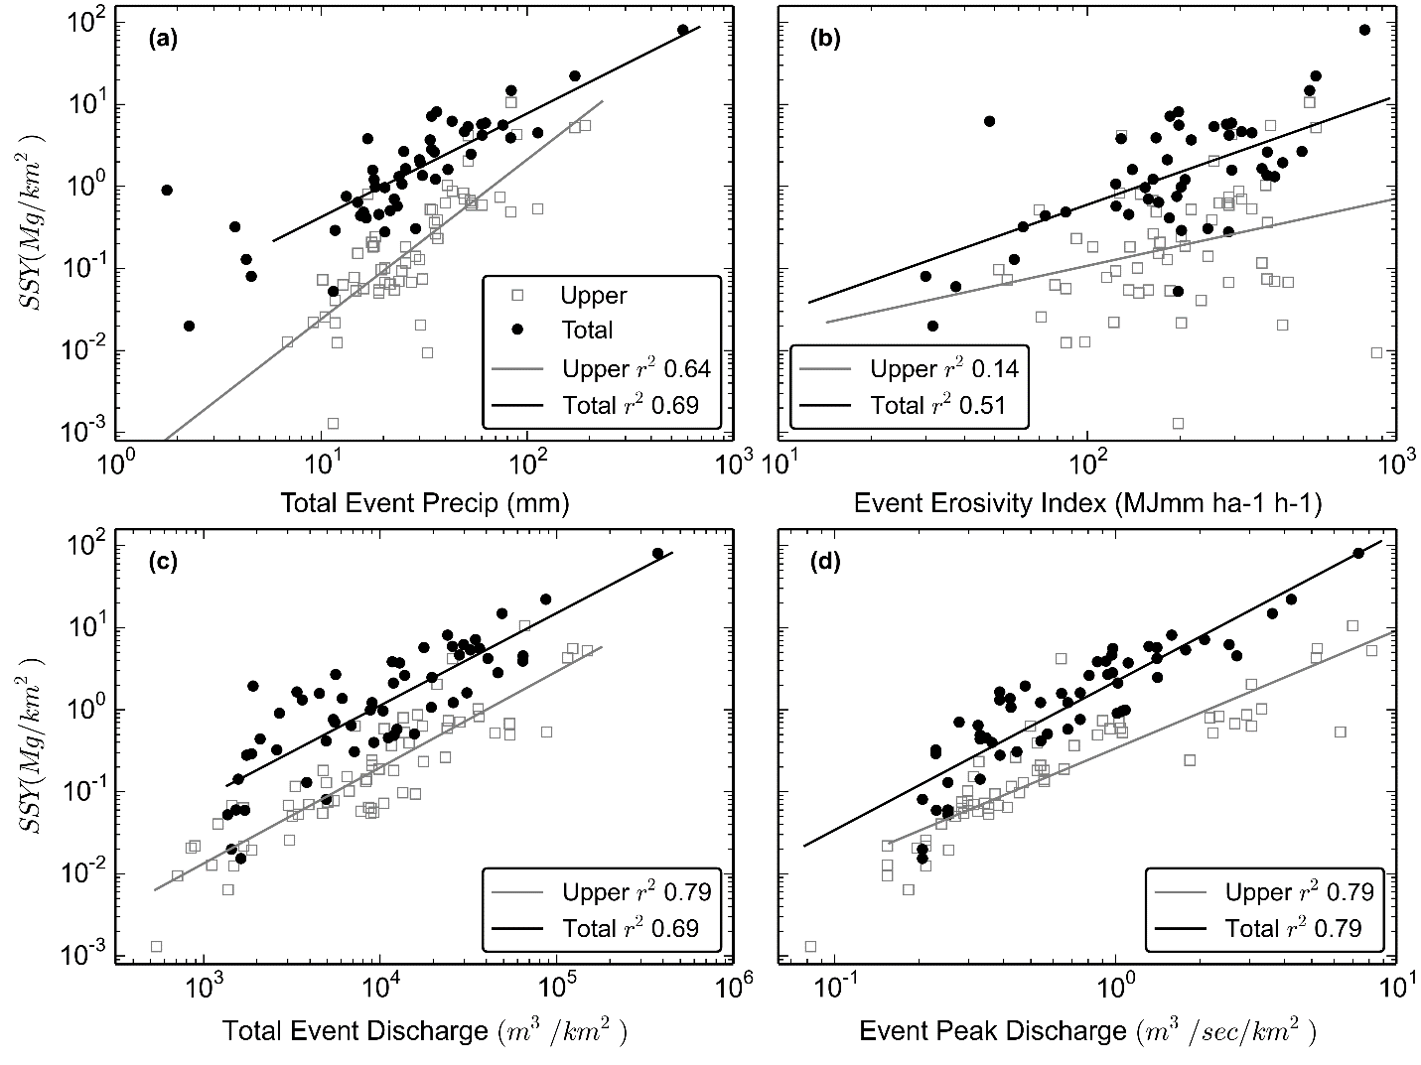

Figure 7. Storm event sediment yield (tons/km2) from the upper watershed (undisturbed forest, FG1 in Figure 5), and from the total watershed (including the quarry and village, FG3 in Figure 5), versus (a) rainfall, (b) rainfall erosivity, (c) event discharge, and (d) event peak discharge. Each point represents the SSY for a single storm event. SSY for the disturbed watershed is higher than for undisturbed upper watershed, indicating human disturbance in the quarry and village has increased SSYEV above natural levels. Qpeak (d) showed the best model fit (r2 = 0.79) for both the Upper and Total watersheds. This model can be used to predict pre-mitigation SSY and compare to post-mitigation SSY, illustrating the effectiveness of mitigation. By reducing SSY through mitigation at the quarry, SSY measured during storms post-mitigation should plot on the model for the upper watershed, indicating SSY from the watershed is back to the natural baseline SSY.

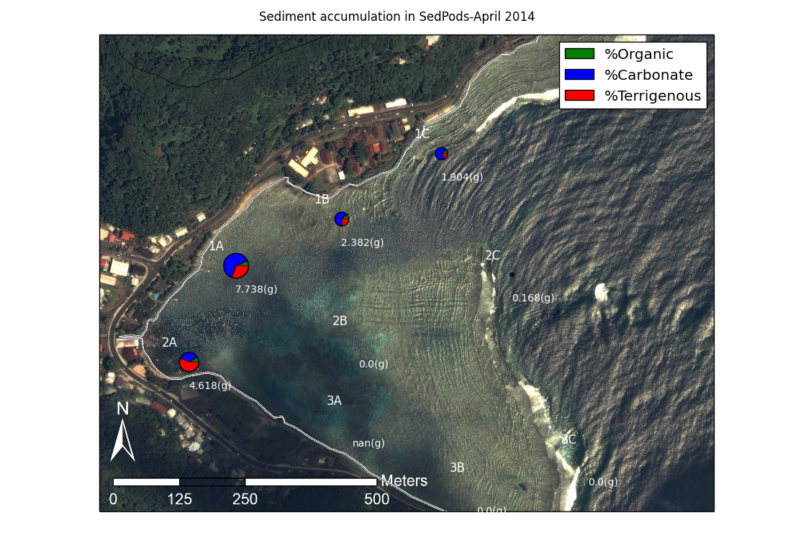

Figure 8. Map showing locations of co-located SedPods and tubes, and sample plots with amounts (circle size) and the organic, carbonate and terrestrial fractions, for one month of sedimentation in April 2014.

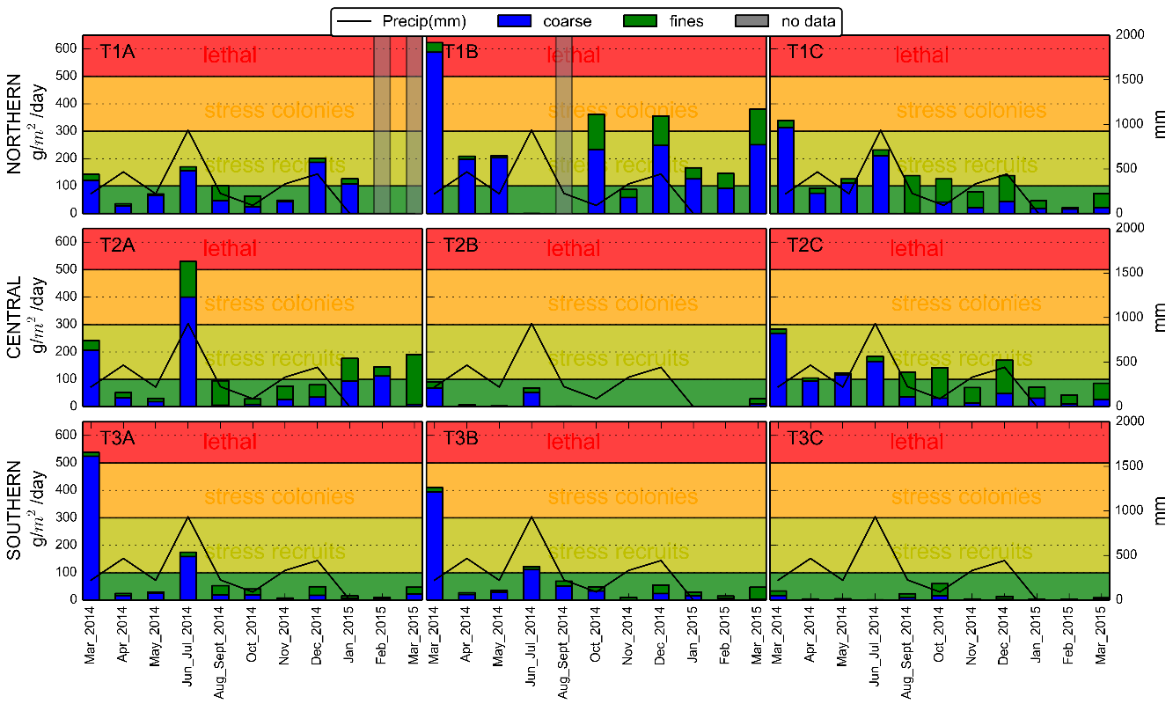

Figure 9. Time series of sediment accumulation in the tubes, March 2014-March 2015. Health thresholds vary by coral species but most sources agree sedimentation rates over 500 g/m2/day are usually lethal (Erftemeijer et al., 2012; Fabricius, 2005).

**Outlook: Anticipated changes due to mitigation activities**

We expect that the mitigation activities at the quarry will have immediate impacts on sediment loading in the stream. Prior to the installation of the two large sediment retention basins in 2014, in ca. August 2012 several mitigation measures were implemented at the quarry including: 1) cessation of manually washing fine sediment from crushed rock, 2) covering the haul roads and platforms in crushed rock to decrease the amount of exposed soil, and 3) diverting groundwater run-on from the quarry blast face through a gravel drain to the stream before it could flow over the quarry premises. After groundwater run-on was diverted, chronically above-natural SSC during baseflow was reduced downstream of the quarry. The extremely high SSC values observed in early 2012 were not observed following the cessation of rinsing the crushed rock and covering the roads in gravel (Figure 6). Preliminary observations suggest that the large retention basins are successfully retaining runoff and sediment generated at the quarry during storms, resulting in immediate qualitative improvement of stream SSC. Results from sampling in 2014-2015 will provide quantitative estimates of those impacts for several storms.

The main long term challenge will be to maintain the retention capacity of the ponds. Ponds fill up with both water and sediment, and their effectiveness will likely deteriorate between cleanings. There may be reduced retention capacity, particularly after large events. Proper maintenance of the ponds is essential for continued effectiveness of the ponds as tools for sediment mitigation. See Appendix A.

The impact of reduced sediment loading on sedimentation rates observed in the bay is more uncertain and may have a temporal lag of several years to a decade. Sediment in reefs systems can have residence times of years to decades or more, and resuspension of those sediments can result in continued turbidity and deposition on the SedPods and the reef (Brodie et al., 2012). We do anticipate that the accumulation of terrigenous sediment will decrease after the mitigation activities, possibly more quickly than the reduction in sedimentation rates.

**Section 2. Comprehensive baseline assessment of coral reef community structure and demographics in Faga`alu Bay, American Samoa**

Bernardo Vargas-Ángel

*NOAA Pacific Islands Fisheries Science Center, Coral Reef Ecosystem Division*

**Significance**

The reef at Faga’alu Bay, American Samoa, is severely affected by siltation stress, due to excessive terrigenous runoff resulting from prolonged and deficient land use practices within the boundaries of the adjacent watershed. Additional secondary impacts to reef corals and associated communities in the Bay include nutrient loading (nitrogen and phosphorus), lowered levels of dissolved oxygen, and elevated bacterial counts from urbanization and inadequate waste management. By documenting coral reef benthic community structure and demographic parameters in a spatially comprehensive manner, this work provides baseline information that is critical to evaluate the effectiveness of reef-to-ridge management practices aimed at reducing land-based sources of pollution threats in Faga’alu Bay, American Samoa. This information is also of use as the basis to track and improve water quality, enhance ecosystem resilience, and update coral reef protection measures.

**Methods**

A stratified random sampling design was implemented to survey the coral reef communities at Faga’alu; the survey domain encompassed ~90% of the mapped area of reef and hard bottom habitat, which was divided into four strata based on reef zone (backreef and forereef) and location (north and south). Allocation of sampling effort was relative to strata area and sites were randomly selected within each stratum. Rapid ecological assessments, totaling surveys at 40 sites (Fig 10) were conducted between March 2012 and August 2013 by staff of NOAA’s Coral Reef Ecosystem Division (CRED), with three sites (north bay, south bay, and ava channel) marked permanently for future visits and reassessments.

At each site, the belt-transect method, with two 25-m transect lines as the focal point of the survey was implemented to quantitatively assess benthic community structure and demographics. Along each transect, five 2.5-m2 segments were surveyed (0–2.5 m; 5.0–7.5 m; 10–12.5 m; 15–17.5 m; 20–22.5 m), whereby all coral colonies whose center fell within 0.5 m on either side of each transect line were identified to the highest possible level of taxonomic detail and measured for two planar size metrics: maximum diameter and diameter perpendicular to the maximum diameter (NOAA 2015). Coral recruits (defined as attached colonies smaller than 5 cm in diameter) were also quantified, measured, and identified to the highest possible level of taxonomic detail. For each coral colony identified within belt-transect surveys, the extent of mortality – both recent and old – were estimated, dedicating special attention to any evidence of disease and sediment-related damage or stress. In addition, the Line-Point-Intercept methodology at 25 cm intervals was implemented to derive information on benthic percent composition, relative abundance, and cover (NOAA 2015).

Figure 10 –Location of the benthic sites surveyed at Faga’alu Bay, American Samoa, between March 2012 and August 2013. Backreef sites indicated in orange and forereef sites indicated in yellow. Red symbols indicate permanent sites; 2 backreef and 1 forereef. All sites were selected using a stratified random design.

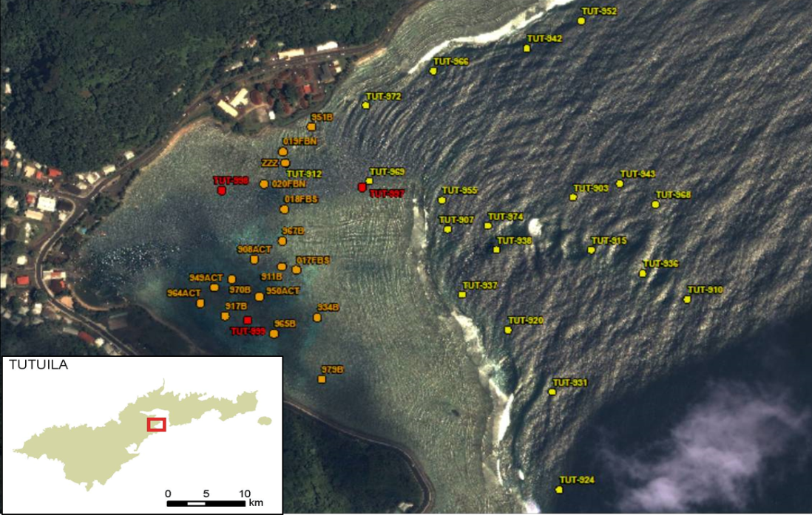

**Data Analysis**

***Analysis of benthic community structure and demographics data***

Spatial patterns of mean percent coral cover and colony densities were tested implementing independent two-way ANOVA models, using reef zone (backreef vs. forereef) and location (north vs. south) as factors. Cover data was ln-transformed to fulfill parametric statistical requirements. ANOVA analyses were performed using SYSTAT 12 version 12.02.00 (SYSTAT 2007).

**Baseline values**

*Benthic composition and community structure*

The quantitative survey data support the benthic community patterns that previously had been anecdotally reported and observed in the field: coral development is conspicuously prominent along the southern portions of the reef in Faga`alu Bay (Fig. 11a, b, 12), compared to the northern areas, where coral development is limited and depauperate (Fig. 11c, d, 12).

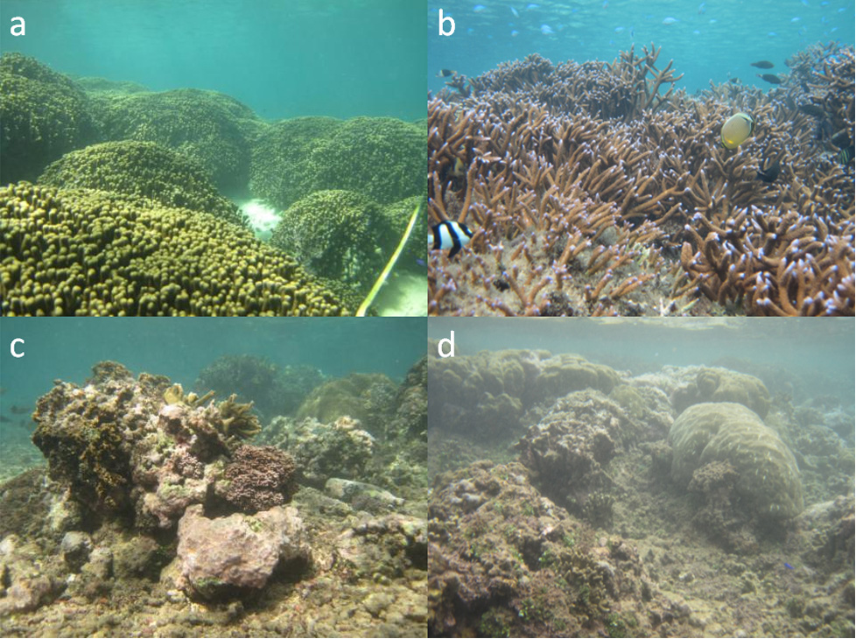

Figure 11–Visual, spatial comparison of coral growth, development, and appearance of shallow habitats of the (a, b) south and (c, d) northern areas of the backreef in Faga`alu Bay, American Samoa. NOAA photos by Bernardo Vargas-Ángel.

Figure 12. Spatial comparison of mean benthic percent cover of shallow habitats of the northern and southern backreef and forereef areas in Faga’alu Bay, American Samoa, derived from line-point-intercept surveys conducted in March 2012 and August 2013.

Mean percent live coral cover was nearly twice as high along the southern area of the reef compared to the northern sector (Fig. 12, 13a, Table 1) and those differences were significant; differences between forereef and backreef were non-significant with no interaction effects between factors (Table 1). Levels of crustose coralline algae were not distinctly different between the northern and southern sectors of the reef (16.8% SE 3.4, 22.5% SE 0.26, respectively), but statistically greater on the forereef compared to the backreef) (Fig. 12, 13b) (two-way ANOVA, P=0.26; P=0.004, respectively). And, percent cover of turf algae was significantly different between reef zones and location; no factor interaction effects however (two-way ANOVA, P<0.009; P=0.002, respectively) (Fig. 12, 13c, Table 1). The northern areas of the reef in Faga`alu Bay are directly affected by terrigenous siltation and runoff. Surveys corroborate this appraisal, as exemplified by the “reef-builder ratio,” which is the proportion of corals and crustose coralline algae to non-carbonate accreting organisms (macroalgae and turfalgae) calculated with values of mean percent cover. The reef-builder ratio was greater along the southern backreef and forereef than along the coral-impoverished northern reef and those differences were statistically significant (two-way ANOVA, P<0.002; P=0.23, respectively) (Fig. 12, 13d, Table 1).

**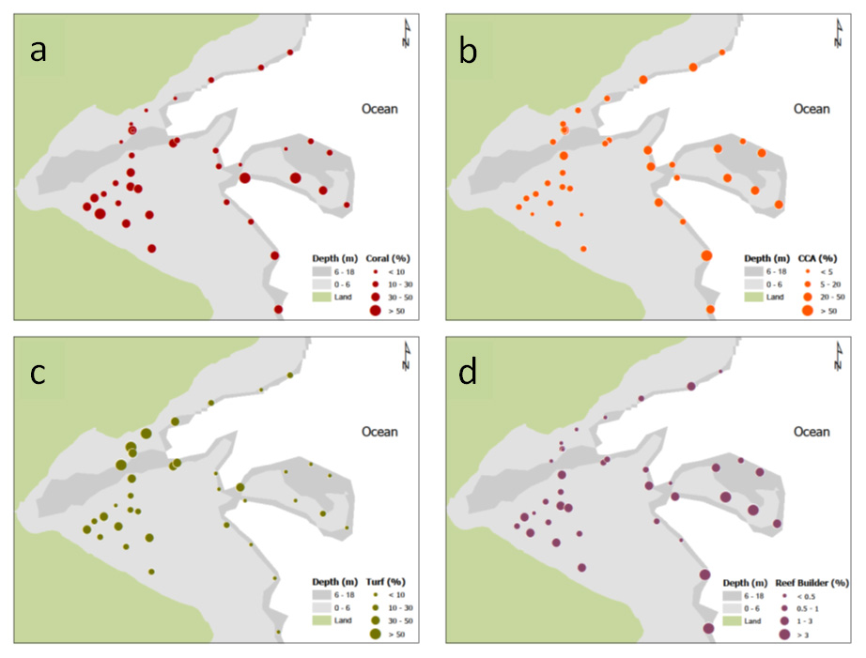**

Figure 13 –Spatial comparison of mean cover (%) values for (a) live hard corals, (b) crustose coralline algae (CCA), (c) turf algae, and (d) values of the reef-builder ratio (ratio of mean cover for corals and crustose coralline algae combined to cover for non-accreting organisms) from line-point-intercept surveys conducted in March 2012 and August 2013 in Faga`alu Bay.

|  |  |  |  |  |  |  |  |  |
| --- | --- | --- | --- | --- | --- | --- | --- | --- |
| Table 1. Summary statistics and P values for two-way ANOVA models run for mean percent benthic cover (% ± SE) and mean coral colony densities (col/m2 ± SE), based on line-point-intercept surveys conducted in August 2012 and March 2012 in Faga’alu Bay. Data were ln-transformed or square root-transformed (\*) to comply with parametric statistics requirements. | | | | | | | | |
|  | | **Location** | | | **Reef zone** | | | **Location x Reef zone** |
|  | | **North** | **South** | **P** | **Backreef** | **Forereef** | **P** | **P** |
| Cover | |  |  |  |  |  |  |  |
|  | Coral | 13.7 ± 2.7 | 30.2 ± 2.7 | 0.004 | 28.9 ± 3.6 | 23.6 ± 3.3 | 0.33 | 0.48 |
|  | CCA | 16.8 ± 3.4 | 22.5 ± 2.5 | 0.26 | 13.3 ± 1.6 | 27.3 ± 2.9 | 0.004 | 0.71 |
|  | Turf | 37.8 ± 7.1 | 18.1 ± 2.9 | 0.009 | 33.3 ± 4.3 | 14.3 ± 3.3 | 0.002 | 0.59 |
|  | Macroalgae\* | 24.0 ± 4.8 | 24.2 ± 3.5 | 0.40 | 15.8 ± 3.3 | 30.5 ± 4.0 | 0.11 | 0.97 |
|  | Reef builder | 0.6 ± 0.2 | 2.2 ± 0.6 | 0.002 | 1.1 ± 0.2 | 2.4 ± 0.8 | 0.23 | 0.62 |
| Density | |  |  |  |  |  |  |  |
|  | Coral | 9.3 ± 1.7 | 13.4 ± 0.9 | 0.006 | 12.2 ± 1.3 | 12.9 ± 1.2 | 0.02 | <0.001 |

*Colony densities and condition*

Figure 14a illustrates estimates of colony density of 6 important reef-building coral genera in Faga`alu Bay. Colony densities for all coral taxa combined were higher along the southern backreef and forereef (13.44 colonies/m2, SE 0.99) than along the northern sector of the reef (9.34 colonies/m2, SE 1.70), and these differences were statistically significant (two-way ANOVA, P=0.06); differences between reef zones were statistically significant (two-way ANOVA, P=0.02) and there was an interaction effect between factors, indicating a clear segregation of the four strata when considering reef location (Table X). Additional differences in coral generic composition and density were evident: corals of the genus *Porites* were heavily dominant along the shallow northern backreef while corals of the genus *Montipora* occurred primarily along the channel and southern forereef. Additional notable spatial and structural differences indicated a preponderance of encrusting and foliose corals of the genera *Montipora* and *Pavona*, respectively, along the shallow northern backreef and, in contrast, the presence of branching corals of the genus *Acropora* throughout the southern backreef. Fast-growing branching corals, such as *Acropora*, appear to be better adapted to the shallow, well-lit habitats of the southern backreef, compared to encrusting and foliose species that appeared to tolerate the lower levels of light and conditions of higher turbidity prevalent on the northern backreef (Rodgers 1990; Crabbe and Smith 2005). Differences among habitats also were observed in values of coral generic richness (Fig 14b), with a greater mean number of genera occurring along the deeper forereef (10.95, SE 0.67) compared to the shallow backreef (6.29, SE 0.25), and these differences also were statistically significant (*P*=0.001, Student’s *t*-test). Such variation is expected given the disparate range of environmental conditions (for example, light, depth, water circulation) of available microhabitats present on the forereef compared to the shallow, relatively homogeneous backreef.

Except for one site on the southern backreef, low levels of bleaching were commonplace across habitats and depths in Faga`alu Bay (Fig. 15). Similarly, mean prevalence of coral disease was low (0.1%, SE 0.02) overall; however, non-tissue loss lesions resulting in compromised health were greater at north-facing backreef sites (0.77%, SE 0.39) than at south-facing sites (0.62%, SE 0.12). Although small, these differences could be associated with the elevated, chronic terrigenous runoff and sedimentation that affects these areas (Pollock et al. 2014).

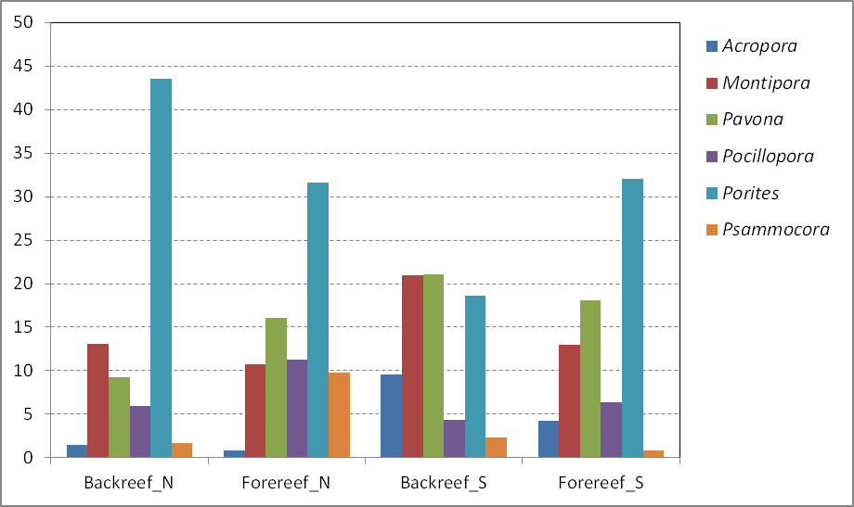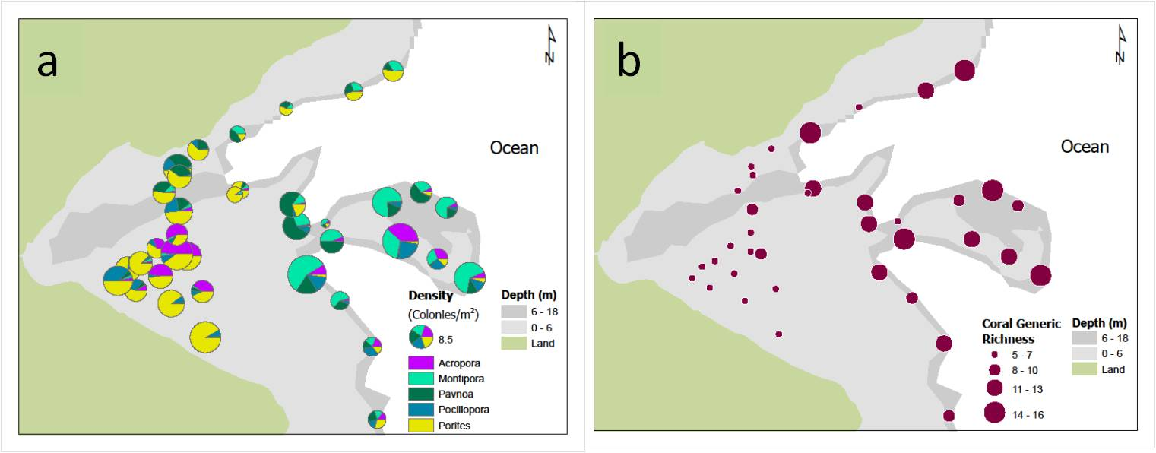

Figure 14 –Spatial comparison of (a) coral-colony density (colonies/m2) and (b) total coral generic richness from belt-transect surveys conducted in March 2012 and August 2013 in Faga`alu Bay. The color-coded bars indicate densities of selected dominant coral genera.

a

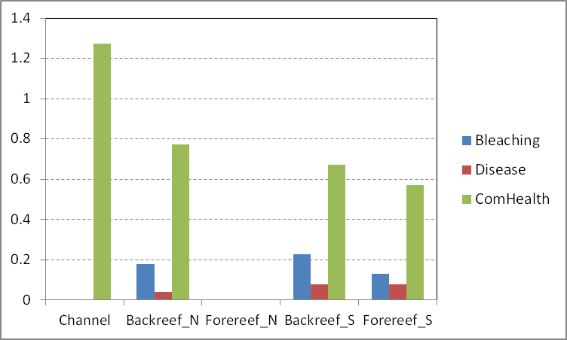

Figure 15 –Spatial comparison of prevalence (%) of bleaching and disease from belt-transect surveys conducted in March 2012 and August 2013 in Faga`alu Bay.

**Outlook: Anticipated changes due to mitigation activities**

In actively growing coral reefs, calcifying organisms including corals, crustose coralline algae, and other carbonate-accreting taxa, typically dominate the shallow, well-lit habitats. In contrast, communities dominated by noncalcifiers, such as turf algae, cyanobacteria, and other macroalgae, are common in areas with suboptimal conditions. In addition to the elevated levels of turf and macroalgae, regardless of the cause, reductions in coral dominance often results in increased rates of bioerosion, leading to gradual destruction of the reef framework and habitat loss (Glynn and Maté 2007). Impacts to the benthic communities in Faga’alu Bay, particularly corals, result from the combined effects of increased turbidity, sedimentation, and nutrient influx. Although upslope quarry mitigation activities are expected to result in changes to the composition and structure of the adjacent coral reef benthos, the spatial and temporal constructs of these changes, may observe protracted lags ranging from years to decades.

Because turf and macroalgal communities can quickly respond to changes in water quality conditions, once established, these turf- and algal-dominated communities can be difficult to reverse. Algae that dominate benthic communities following acute and chronic environmental disturbances can be hardy, chemically defended species, including filamentous cyanobacteria which are relatively unpalatable to herbivores (Fong and Paul 2011). Terrigenous sedimentation and siltation stress is often accompanied by increased nutrient levels which facilitate algal proliferation. As such, preserving and promoting healthy fish and invertebrate herbivore communities will be pivotal to the reestablishment of functional coral communities at Faga’alu, particularly those along the northern portion of the reef which exhibit the greatest levels of siltation impact. It can be speculated that the first signs of change may be quantifiable as reductions in the cover of fleshy macroalgal elements and an increase in calcifying coralline algae. However, because corals exhibit a lesser competitive superiority compared to algae, their recovery will depend on the reduction of the algal populations, together with improvement of water clarity, the reduction of excess sediment and nutrient inputs, as well as the availability and establishment of recruits.

One element to consider however is the fact that the northern shallow reef is located under the direct influence of the drainage of the Faga’alu stream. Recurrent, low-salinity pulses associated with heavy downpours and storm flood events can be implicated with decreased levels of calcification and potentially lesser development of corals and other calcifying reef-dwelling benthos (see Jokiel et al. 1993). In addition, the historic Landfill located on the premises of the current Matafao Elementary School site is potentially a source of contaminants, particularly arsenic, which may preclude, or delay the recovery of shallow benthic assemblages on this side of the fringing reef (see Downs et al. 2005).

**Section 3. Contaminant Pollution in Surface Sediments of Faga’alu Bay and Watershed, American Samoa**

David Whitall

*NOAA National Centers for Coastal and Ocean Science, Center for Coastal Monitoring and Assessment, Coastal & Oceanographic Assessment, Status and Trends*

**Significance**

Despite their ecological, economic and cultural value, over half of the world’s coral reefs are threatened by human activity (Bryant *et al.*, 1998). Increased runoff of sediment, nutrients, and pollutants has been correlated to the degradation of coral reefs (Fabricius, 2005). Although pollution is a known cause of the decline of coral reefs, details of the relationship between contaminants and corals are not well understood. There are currently no established thresholds for individual pollution stressors indicating concentration limits above which corals are harmed.

This study presents a baseline assessment of the magnitude and spatial distribution of pollution in the coral reef ecosystem of Faga’alu Bay. This information will provide ecosystem managers a reference point against which to evaluate the success of upland watershed best management practices.

**Methods**

1. SAMPLING DESIGN

A stratified random sampling design allowed this study to assess the overall contaminant condition of the ecosystem, and to be able to make geographically explicit conclusions about how pollutants vary spatially. In this method, all areas within a stratum had an equal chance of being selected as a sampling site. The four strata were: Inner Bay, South Bay, North Bay and Channel. Additionally, four targeted sediment sites were selected in the watershed and one targeted site was sampled near the school/landfill. A total of seventeen sediment sites were sampled in January of 2014.

1. FIELD SAMPLING

Sediment samples were collected using standard NOAA National Status and Trends (NS&T) Program protocols (Lauenstein and Cantillo, 1998). Briefly, surface sediment samples (top 2 cm) were collected directly into certified pre-cleaned HPDE 250 ml jars. Field personnel wore disposable nitrile gloves to prevent cross contamination between sites. Jars were stored on ice while in the field, then kept frozen until analysis.

1. LABORATORY ANALYSES

Sediment samples were analyzed via standard NS&T techniques at the NS&T contract lab (TDI Brooks International, College Station, Texas). Detailed analytical methods can be found in Kimbrough *et al.* 2006 and Kimbrough and Lauenstein 2006. Briefly, PAHs were analyzed in the laboratory using gas chromatography/mass spectrometry in the selected ion monitoring (SIM) mode (Kimbrough *et al.* 2006). Selected chlorinated organics (PCBs and pesticides) were analyzed using gas chromatography/electron capture detection (Kimbrough *et al.* 2006). Butyltins were analyzed using gas chromatography/flame photometric detection (Kimbrough *et al.* 2006).

Silver, cadmium, copper, lead, antimony, and tin were analyzed using inductively coupled plasma - mass spectrometry. Aluminum, arsenic, chromium, iron, manganese, nickel, silicon and zinc were analyzed using inductively coupled plasma - optical emission spectrometry. Mercury was analyzed using cold vapor - atomic absorption spectrometry. Selenium was analyzed using atomic fluorescence spectrometry (Kimbrough and Lauenstein et al. 2006). For each element, total elemental concentration (i.e. sum of all oxidation states) was measured.

**Data Analysis**

**Statistical Analysis**

Because the data were not normally distributed, a non-parametric multiple comparisons test (Dunn Method for Joint Ranking, =0.05) was used to evaluate differences among strata. Because they were not randomly selected, the targeted sites (four watershed sites, plus one site by the school) were included in the summary statistics for the entire study area, but were excluded from the statistical analysis of differences between strata. Spearman Rank correlations (=0.05) were examined to evaluate the relationships between sediment variables.

*Providing Context for Results*

In addition to comparing contamination results between strata, these findings can be compared to previously published numerical sediment quality guidelines (SQG) known as ERL (effects range-low) and ERM (effects range-median) developed by Long and colleagues (Long and Morgan, 1990; Long *et al*., 1995, Long et al. 1996, Long et al. 1998, Long and MacDonald, 1998). For the purposes of discussion, when a sample exceeds the ERM, toxicity to benthic infauna is said to be probable. When a sample exceeds the ERL but not the ERM, toxicity to benthic infauna is possible. It should be noted that SQG were designed for marine systems, so they are not directly applicable to freshwater stream sites. Stream sites are included here purely for reference. It is also important to note that SQG do not consider the additive impact of multiple pollutants on organisms.

**Baseline Values and Key Findings**

In general, pollution in Faga’alu Bay is relatively low. The ERM sediment quality guidelines were exceeded only for nickel (1 site in the watershed and 1 site in the Inner Bay) and zinc (1 site in the watershed). This suggests probable toxicity to benthic infauna at these sites. The ERL but not the ERM guideline was exceeded for at least one site for the following analytes: silver, arsenic, chromium, copper, zinc, nickel, chlordane and PCBs (Table 2). This suggests that there is the possibility of toxicity to sediment infauna at these sites. Most analytes are higher in the watershed than in the Bay, suggesting a terrestrial source (e.g. Figure 15). An exception to this is arsenic where the highest value was measured in the North Bay strata (Figure 16). This may be related to the historical land fill located on the current school site. Metals quantified in this study are generally well correlated with crustal elements that are generally not considered to be pollutants (e.g. Al, Fe, Mn, Si). This is particularly true for Zn (Figure 17) and Ni, meaning that despite their relatively elevated sediment concentrations, these levels are likely natural and the product of the erosion of watershed bedrock material. Conversely, arsenic is not well correlated with other crustal elements (Figure 18). Legacy organic contaminants (e.g. chlordane, DDTs, PCBs) found in the Bay are likely due to their widespread historical use and environmental persistence, rather than any new sources of those pollutants in the system.

This data set serves as an important baseline against which to measure future change, including the efficacy of ongoing watershed management activities (e.g. improved management practices at the quarry). Although Faga’alu Bay is not especially polluted with toxic contaminants, there are some reasons for concern, including potential leaching of metals and organics from the legacy landfill on the north shore of the Bay. Furthermore, crustal element loads may decrease following changes in management practices at the quarry, which could be quantified with future sampling.

**Outlook: Anticipated changes due to mitigation activities**

The mitigation activities discussed above do not directly target sources of contaminants to the Bay. However, if mining activities at the quarry are increasing the rate at which naturally occurring crustal metals (e.g. nickel and zinc) were reaching the Bay, best management practices at the quarry designed to reduce sediment flux may have the added effect of decreasing the crustal metal flux to the Bay. It should be noted that unlike organic contaminants (e.g. DDT, PCBs) which decay over time into less harmful compounds elemental metals do not degrade. As a result, decreases in sediment (and therefore metal) load may not result in decreases in sediment metal concentrations, unless metals are being otherwise removed from the system. For example, metals may become less bioavailable (i.e. through burying by new sediments), may be taken up by biology, or may be flushed from the system during extremely large storm events.

Additionally, data presented in this study suggest that the legacy landfill could be a source of some pollutants to the Bay. This warrants further research, including groundwater measurements, and could require additional mitigation activities in the future.

Additional Information

More detailed analysis, including maps, graphs and statistics will be available in a published NOAA technical memorandum (scheduled publication date May 2015). Please contact Dr. David Whitall ([dave.whitall@noaa.gov](mailto:dave.whitall@noaa.gov)) with technical questions.

Table 2: Summary statistics for sediment samples in Faga’alu Bay and watershed (January 2014). Summary statistics include targeted (e.g. watershed) sites.

|  |  |  |  |  |  |  |  |
| --- | --- | --- | --- | --- | --- | --- | --- |
| **Analyte** | **Units** | ***Min*** | ***Max*** | ***Mean*** | ***Median*** | ***StDev*** | ***Number of Sites Exceeding ERL/ERM*** |
| **Ag** | ug/g | 0 | 2.74 | 0.49 | 0 | 0.81 | 4/0 |
| **Al** | ug/g | 475 | 72400 | 25682 | 8250 | 28817 | NA |
| **As** | ug/g | 1.19 | 11.5 | 4.44 | 3.91 | 2.90 | 3/0 |
| **Cd** | ug/g | 0 | 0.31 | 0.10 | 0.07 | 0.09 | 0/0 |
| **Cr** | ug/g | 7.13 | 191 | 39.47 | 25.7 | 46.42 | 1/0 |
| **Cu** | ug/g | 0 | 37.7 | 8.53 | 5.74 | 9.67 | 1/0 |
| **Fe** | ug/g | 712 | 103000 | 28484 | 18300 | 29827 | NA |
| **Hg** | ug/g | 0.000764 | 0.0163 | 0.01 | 0.01 | 0.00 | 0/0 |
| **Mn** | ug/g | 20 | 1250 | 467 | 184 | 495 | NA |
| **Ni** | ug/g | 4.19 | 211 | 35.13 | 12.6 | 50.66 | 4/2 |
| **Pb** | ug/g | 0.641 | 45.5 | 13.15 | 8.46 | 12.93 | 0/0 |
| **Sb** | ug/g | 0 | 0.472 | 0.18 | 0.196 | 0.15 | NA |
| **Se** | ug/g | 0 | 0.127 | 0.02 | 0 | 0.04 | NA |
| **Si** | ug/g | 105 | 256000 | 74608 | 13300 | 97244 | NA |
| **Sn** | ug/g | 0.27 | 15.40 | 4.50 | 4.37 | 3.73 | NA |
| **Zn** | ug/g | 3.70 | 416.00 | 109.69 | 53.70 | 119.72 | 3/1 |
| **Total PAHs** | ng/g | 1.35 | 2097.48 | 177.80 | 27.49 | 501.36 | 0/0 |
| **Total HCH** | ng/g | 0 | 0.10 | 0.03 | 0 | 0.04 | NA |
| **Total Chlordane** | ng/g | 0 | 4.60 | 0.62 | 0 | 1.30 | 5/0 |
| **Total DDT** | ng/g | 0 | 2.29 | 0.23 | 0.11 | 0.54 | 1/0 |
| **Total PCBs** | ng/g | 2.19 | 92.89 | 14.35 | 2.32 | 29.06 | 3/0 |
| **Monobutyltin** | ng/g | 0 | 2.00 | 0.18 | 0 | 0.54 | NA |
| **Dibutyltin** | ng/g | 0 | 0.60 | 0.08 | 0 | 0.17 | NA |
| **Tributyltin** | ng/g | 0 | 0.98 | 0.07 | 0 | 0.24 | NA |
| **Tetrabutyltin** | ng/g | 0 | 0 | 0 | 0 | 0 | NA |
| ***Clostridium perfringens*** | CFU/g | 0 | 1722 | 302 | 125 | 432 | NA |

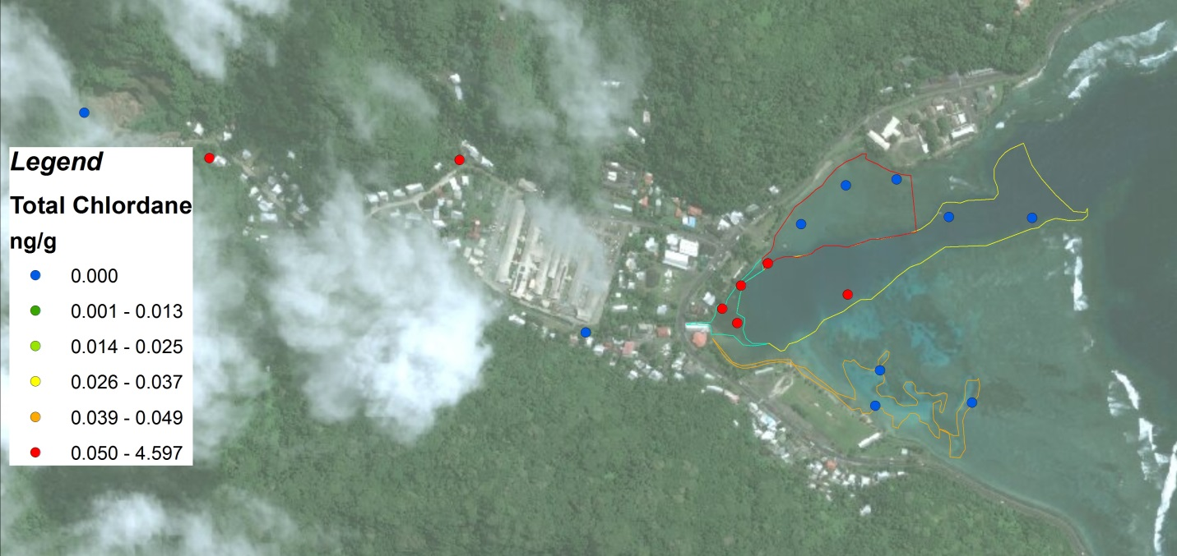

Figure 15: Total chlordane concentrations in sediments (January, 2014). This is a representative figure showing a strong watershed pollutant source.

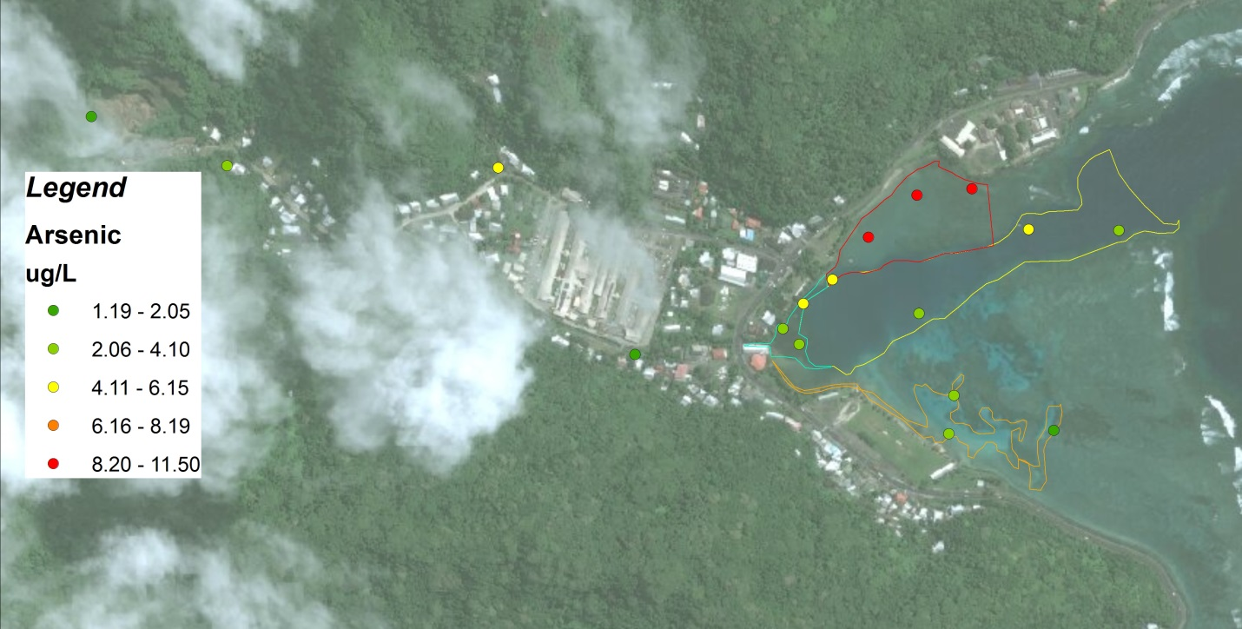

Figure16: Arsenic concentrations in sediments (January, 2014). Note: highest concentration are in the North Bay area.

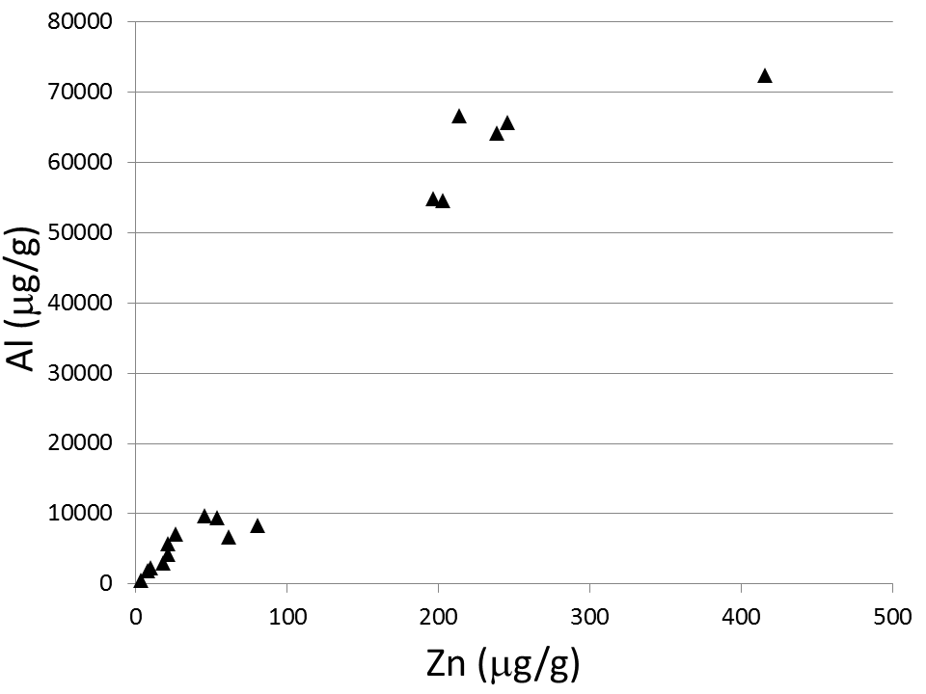

Figure 17: Scatter plot of sediment Zn versus sediment Al. The high degree of correlation between these two crustal elements (Spearman rho=0.96 ) suggests that even though Zn exists at high levels, this is most likely naturally occurring Zn.

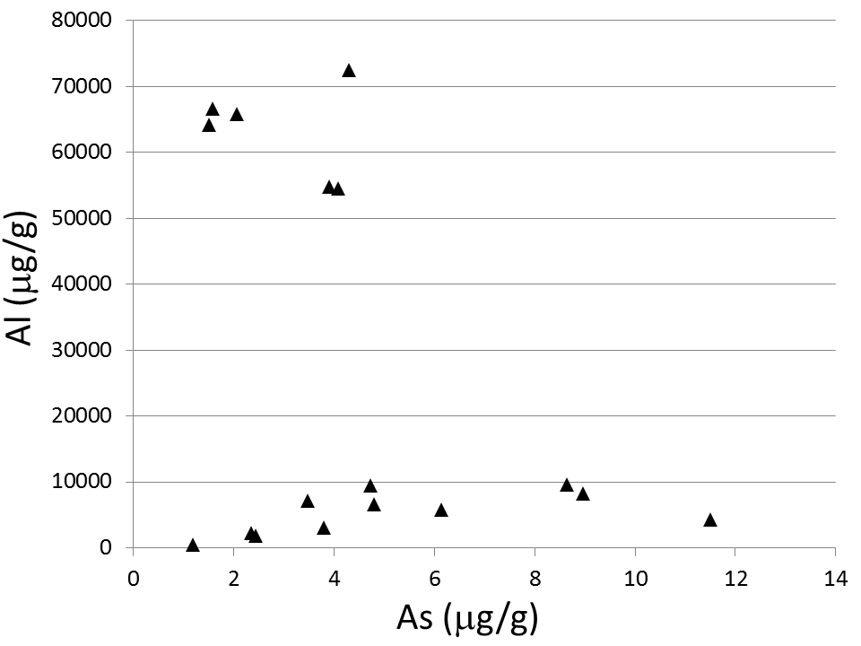

Figure 18: Scatter plot of sediment As versus sediment Al. The lack of correlation between these two crustal elements suggests that high arsenic levels are likely due to anthropogenic sources.

**Summary and Recommendations**

I’ve made comments in each of the sections regarding information to include in this section – can you please review those and add in anything I missed?

Contacts of partners and contributors?

**References**

[Crabbe](http://www.springerlink.com/content/?Author=M.+James+C.+Crabbe" \o "View content where Author is M. James C. Crabbe) MJC, [Smith](http://www.springerlink.com/content/?Author=David+J.+Smith" \o "View content where Author is David J. Smith) DJ.

2005. Sediment impacts on growth rates of *Acropora* and *Porites* corals from fringing reefs of Sulawesi, Indonesia. Coral Reefs 24:437–441

Downs CA, Fauth JE, Robinson CE, Curry R, Lanzendorf B, Halas JC, Halas J, Woodley CM.

2005. Cellular diagnostics and coral health: Declining coral health in the Florida Keys. Mar. Poll. Bull. 51: 558–569

Fong P, Paul VJ.

2011. Coral Reef Algae. In: Dubinsky Z, Stambler N. (eds). Coral Reefs: An Ecosystem in Transition. Springer Science + Business Media B.V pp. 241-272

Jokiel PL, Hunter CL, Taguchi S, Watarai L.

1993. Ecological impact of a fresh-water “reef kill” in Kaneohe Bay, Oahu, Hawaii. Coral Reefs. 12: 177–184

NOAA

2010. American Samoa’s Coral Reef Management Priorities. The Territory of American Samoa and NOAA Coral Reef Conservation Program. Silver Spring, MD. Available at: <http://coralreef.noaa.gov/aboutcrcp/strategy/reprioritization/managementpriorities/resources/amsam_mngmnt_clr.pdf>

NOAA

2015. Pacific Islands Fisheries Science Center, Coral Reef Ecosystem Division, Survey Methods. Available at: [http://www.pifsc.noaa.gov/cred/survey\_methods.php#benthic\_monitoring\_rea](http://www.pifsc.noaa.gov/cred/survey_methods.php" \l "benthic_monitoring_rea). Accessed January 2015.

Pollock FJ, Lamb JB, Field SN, Heron SF, Schaffelke B, Shedrawi G, Bourne DG, Willis BL.

2014. Sediment and turbidity associated with offshore dredging increase coral disease prevalence on nearby reefs. PLoS ONE 9(7): e102498. doi:10.1371/journal.pone.0102498

SYSTAT®

(2007) SYSTAT 12 Statistics\_I\_II\_III\_IV. SYSTAT Software Inc., San Jose, California.

Houk 2013.

References

Bryant, D., Burke, L., McManus, J., Spalding, M. *Reefs at Risk: A Map-based Indicator of Threats to the World’s Coral Reefs*. World Resources Institute, Washington, DC, 1998.

Fabricius, K.E.. Effects of terrestrial runoff on the ecology of corals and coral reefs: review and synthesis. 2005. *Mar. Poll. Bull.,* 50, 125–146.

Kimbrough, K.L. and G.G. Lauenstein (eds). 2006. Major and trace element analytical methods of the National Status and Trends Program: 2000-2006. Silver Spring, MD. NOAA Technical Memorandum NOS NCCOS 29. 19 pp.

Kimbrough, K.L., G.G. Lauenstein and W.E. Johnson (eds). 2006. Organic contaminant analytical methods of the National Status and Trends Program: Update 2000-2006. NOAA Technical Memorandum NOS NCCOS 30. 137 pp.

Lauenstein, G.G., and Cantillo, A.Y. (1998). Sampling and Analytical Methods of the National Status and Trends Program Mussel Watch Project: 1993-1996 Update. U.S. Dept. Comm., NOAA Tech. Memo. 130, NOS ORCA, Silver Spring, Maryland.

Long, E.R. and Morgan, L.G. 1990. The Potential for Biological Effects of Sediment-Sorbed Contaminants Tested in the National Status and Trends Program. NOAA Tech. Memo NOS OMA 52. NOAA, Seattle, WA. 175 pp.

Long, E.R., MacDonald, D.D., Smith, S.L., and Calder, F.D. 1995. Incidence of adverse biologival effects within ranges of chemical concentrations in marine and estuarine sediments. *Environmental Management* 19: 81-97.

Long, E.R., Robertson, A., Wolfe, D.A., Hameedi, J. and Sloane, G.M. 1996. Estimates of the spatial extent of sediment toxicity in major U.S. estuaries. *Environmental Science and Technology* 30(12):3585-3592.

Long, E.R., L.J. Field and D.D. MacDonald. 1998. Predicting toxicity in marine sediments with numerical sediment quality guidelines. *Environmental Toxicology and Chemistry* 17(4): 714-727.

Long, E.R., and D.D. MacDonald. 1998. Recommended uses of empirically derived, sediment quality guidelines for marine and estuarine ecosystems. *Human and Ecological Risk Assessment* 4(5): 1019-1039.

Brodie, J., Wolanski, E., Lewis, S., Bainbridge, Z., 2012. An assessment of residence times of land-sourced contaminants in the Great Barrier Reef lagoon and the implications for management and reef recovery. Mar. Pollut. Bull. 65, 267–79. doi:10.1016/j.marpolbul.2011.12.011

Daly, C., Halbleib, M., Smith, J.I., Gibson, W.P., Doggett, M.K., Taylor, G.H., Curtis, J., Passteris, P.P., 2008. Physiographically sensitive mapping of climatological temperature and precipitation across the conterminous United States. Int. J. Climatol. 28, 2031. doi:10.1002/joc

Erftemeijer, P.L. a, Riegl, B., Hoeksema, B.W., Todd, P. a., 2012. Environmental impacts of dredging and other sediment disturbances on corals: A review. Mar. Pollut. Bull. 64, 1737–1765. doi:10.1016/j.marpolbul.2012.05.008

Fabricius, K.E., 2005. Effects of terrestrial runoff on the ecology of corals and coral reefs: review and synthesis. Mar. Pollut. Bull. 50, 125–46. doi:10.1016/j.marpolbul.2004.11.028

Izuka, S.K., 2005. Potential Evapotranspiration on Tutuila , American Samoa.

Perreault, J., 2010. Development of a Water Budget in a Tropical Setting Accounting for Mountain Front Recharge: Tutuila, American Samoa. University of Hawai’i.

Wong, M., 1996. Analysis of Streamflow Characteristics for Streams on the Island of Tutuila, American Samoa.

**Appendix A:** Operation and Maintenance protocols excerpted from Horsley Witten Basis of Design Memo for Samoa Maritime Erosion and Sediment Control Corrective Action Plan

**8.0 Operation and Maintenance**

The operation and maintenance of the erosion and sediment control practices should be included as part of the daily quarry operations. Daily routine inspections of the site perimeter will identify possible deficiencies in the sediment control measures or areas in need of repair before sediment leaves the site.

Basic ongoing operational control of the site to confine equipment and truck traffic to the designated travel-ways, and keep the redundant sediment control measures clean and operational will result in less sediment leaving the site.

The following provides for the periodic maintenance and inspection items for the various practices on the site. The quarry operator should keep a daily log of activities and conduct and document inspections on a minimum schedule of one inspection per week.

* 1. **Sediment Basins**:
     1. Inspect each sediment basin at least weekly and after each significant (1/2 inch or greater) rainfall event and repair immediately.
     2. Remove sediment and restore the basin to its original dimensions when it accumulates to one-half the design depth. Place removed sediment in an area with sediment controls. Dewatering may be required prior to sediment removal. See plan sheet for dewatering instructions. Care should be taken to avoid direct discharge of turbid water to stream during basin dewatering process.

|  |  |  |  |
| --- | --- | --- | --- |
| Basin | Bottom Elevation | Permanent Pool Elevation | Sediment Removal Elevation |
| #1 Forebay | 118 | 121.5 | ~120 |
| #1 Main Cell | 117 | 120.5 | ~119 |
| #2 | 86 | 89.5 | ~88 |
| #3 | TBD | TBD | TBD |

**Clean Out Guidance**

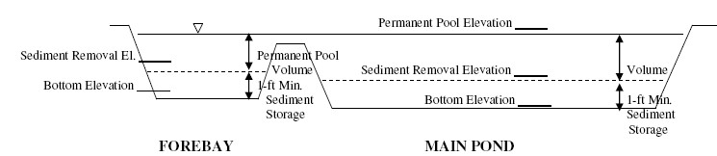

* + 1. Verify the stability and continued function of the baffles.
    2. Check the upstream and downstream face of the embankment in the area of the outlet pipe for any signs of leakage, sloughing of the embankment soil, or erosion.
    3. Inspect the spillways and outlet for erosion damage, and inspect the embankment for piping and settlement. Make all necessary repairs immediately.
    4. Remove all trash and other debris from the riser and pool area.
  1. **Baffles**:
     1. Ensure access to the baffles is maintained.
     2. Inspect baffles at least once a week and after each rainfall. Make any required repairs immediately.
     3. If a baffle collapses, tears, decomposes, or becomes ineffective, replace it promptly.
     4. Remove sediment deposits when reaches half full, to provide adequate storage volume for the next rain and to reduce pressure on the baffles. Take care to avoid damaging the baffles during cleanout, and replace if damaged during cleanout operations. Sediment depth should never exceed half the designed storage depth.
  2. **Channels and Drainage Pipes:**
     1. Inspect each conveyance channel and drainage pipe at least weekly and after each significant (1/2 inch or greater) rainfall event for sediment accumulation or damage to pipe inlets and outlets. Give special attention to the outlet and inlet sections and other points where concentrated flow enters.
     2. Carefully check stability at all culvert inlets and outlets. Look for indications of piping, scour holes, or bank failures.
     3. Repair any damage immediately.
     4. Remove sediment and any other debris.
  3. **Erosion Control Blankets**
     1. Inspect Rolled Erosion Control Products (RECP)at least weekly and after each significant rainfall event (1/2 inch or greater) repair immediately.
     2. Ensure that good contact is maintained with the ground, and that erosion is not occurring beneath the matting.
     3. Any areas of matting that are damaged or not in close contact with the ground shall be repaired and stapled.
     4. Monitor and repair the RECP as necessary until ground cover is established.
  4. **Trench Drains:**

A properly designed and installed subsurface drain requires little maintenance. However, the drains should be checked periodically (and especially after significant rainfall events) to ensure that they are operating properly.

* 1. **Diversion Berms**

Depending on traffic loads and frequency, these diversions will need to be inspected regularly and reshaped as needed to maintain dimensions and to ensure proper function.

**Routine Maintenance:**

Other routine maintenance includes the removal of trash and litter from the site and perimeter areas.